Product Information

Overview of motorcycle accessories,
F 650 GS / F 800 GS

24.01.2008



BMW Motorcycle Equipment

Parts and Accessories

Photos

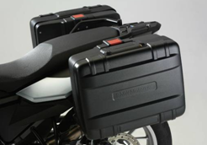  Vario cases | 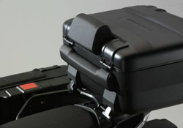  Vario topcase | 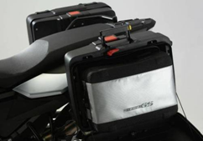  Liners for Vario cases and topcase
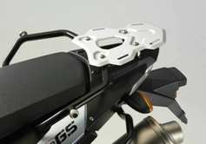  Luggage carrier, small | 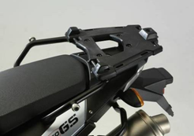  Luggage rack, large  for Vario topcase | 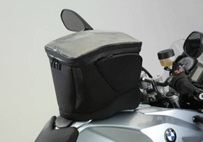  Tank rucksack
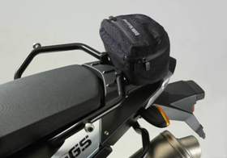  Enduro rear softbag | 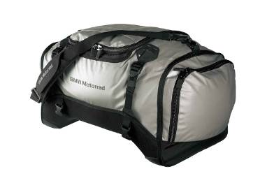  Sport softbag, large | 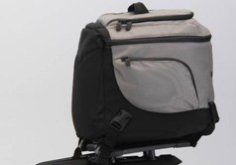  Sport softbag, small

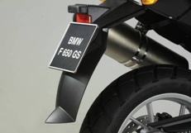  Spray-guard extension, rear | 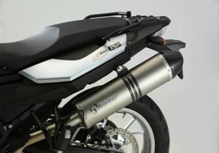  Sports silencer | 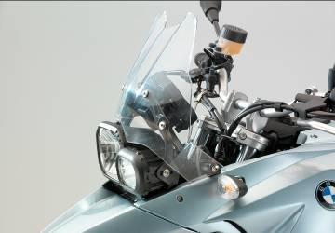  Windscreens (tinted, large...)
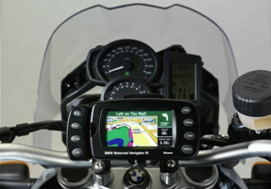  BMW Motorrad Navigator III | 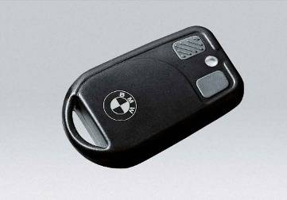  Anti-theft alarm | 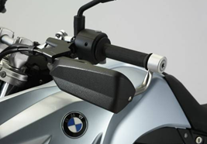  Hand protector
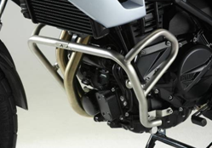  Crash bar | 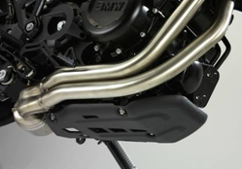  Engine guard, plastic | 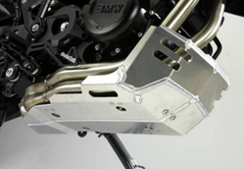  Enduro engine guard, aluminium
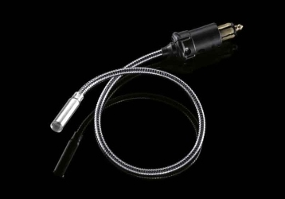

LED light for on-board socket

Order information for motorcycle accessories (1/2)
F 650 GS / F 800 GS

Description | Part number |  | RRP inc VAT
Stowage-equipment line
Vario case, black, left | 71 60 7 696 299 |  | £184
Vario case, black, right | 71 60 7 696 300 |  | £185
(+) Case carrier for Vario case, including fasteners | 71 60 7 696 301 |  | £144
(+) Lock barrel, complete, for 2 cases | 51 25 7 688 566 |  | £20.80
(o) Lock barrel by code for vehicle and/or case matching locks (order 2x) | 51 25 7 681 199 |  | £33.59
(o) Lock-barrel set | 51 25 7 698 202 |  | £15.20
Liner for Vario case, left | 71 60 7 687 610 |  | £67
Liner for Vario case, right, and Vario topcase | 71 60 7 687 611 |  | £67
Vario topcase, black | 71 60 7 696 302 |  | £225
(+) Luggage rack, large, for Vario topcase  (including adapter plate) | 71 60 7 696 303 |  | £64
(+) Lock barrel for topcase | 51 25 7 688 568 |  | £12.50
(o) Lock barrel by code for vehicle and/or case matching locks (order 1x) | 51 25 7 681 199 |  | £33.60
(o) Lock barrels for 2 cases and topcase | 51 25 7 688 567 |  | £29.10
Liner for Vario case, right, and Vario topcase | 71 60 7 687 611 |  | £67
Backrest pad for topcase | 71 60 7 688 877 |  | £45 I
Luggage carrier, small | 71 60 7 701 810 |  | £42.90
Tank rucksack, waterproof | 71 60 7 711 240 |  | £130
Enduro rear softbag | 71 60 7 711 245 |  | £35.90
Sport softbag, small, 19 l | 71 60 7 694 117 |  | £102
Sport softbag, large, 51 l | 71 60 7 693 567 |  | £139
Stuffbag, waterproof, 53 l | 72 60 7 653 818 |  | £90
Luggage strap with pull-tight buckle | 72 60 2 304 808 |  | £6.30
Bungee-cord spider | 72 60 9 057 579 |  | £3.95
Design line
Spray-guard extension, rear | 71 60 7 695 031 |  | £24.20
Sound components
Akrapović sports silencer | 71 60 7 713 339 | *1 | £475
Ergonomics and comfort line
Windscreen, large, tinted | 71 60 7 713 834 | *1 | £138
Windscreen, large, clear (standard for F 800 GS) | 71 60 7 713 833 |  | £127
Windscreen, small, clear (standard for F 650 GS) | 71 60 7 713 296 |  | £87
Centre stand (F 650 GS) | 46 52 7 700 864 | *2 | £83
Centre stand (F 800 GS) | 46 52 7 700 049 | *2 | £91.50
(+) Fasteners for centre stand  (F 650 GS + F 800 GS) | 71 60 7 706 738 |  | £24.90
Seat, low, black,  790 mm (F 650 GS), 850 mm ( F 800 GS) | 52 53 7 695 013 |  | £174
Heated handlebar grips and switches
(see electronic parts catalogue)
Navigation and communication components
BMW Motorrad Navigator III plus 2008 | 72 60 7 716 116 | *1 | £650
(+) Holder for BMW Motorrad Navigator | 71 60 7 697 785 |  | £45.80
(+) Securing screw (order 4 of) | 32 71 7 652 161 |  | £4.55
Connecting cable for BMW Motorrad Navigator | 71 60 7 686 670 |  | £55
TMC module for BMW Motorrad Navigator | 72 60 7 702 687 | *1/3 | £111
Car kit for BMW Motorrad Navigator | 72 60 7 703 996 | *3 | £60.50
Navigator carry-bag function | 71 60 7 683 161 |  | £49
Safety line
Hand-protector bar | 71 60 7 716 043 |  | £57
(+) Countersunk-head screw (order 2 of) | 32 71 7 712 836 |  | £3.34
Hand protector, small | 71 60 7 705 963 |  | £19.50
Hand protector, large | 71 60 7 715 135 |  | £23.10
Protector-mounted spoiler for hand protector, large | 71 60 7 705 964 |  | £15.20
Crash bar, left | 71 60 7 699 437 |  | £104
Crash bar, right | 71 60 7 699 438 |  | £104
(+) Fasteners for crash bar | 71 60 7 702 395 |  | £18.10

Order information for motorcycle accessories (2/2)
F 650 GS / F 800 GS

Description | Part number |  | RRP inc VAT
Engine guard, plastic (standard for F 800 GS) | 11 11 7 700 809 |  | £34.10
(+) Fasteners for engine guard | 71 60 7 704 773 |  | £23.69
Enduro engine guard, aluminium | 71 60 7 702 951 |  | £147
(+) Fasteners for engine guard  (only F 650 GS, standard for F 800 GS) | 71 60 7 704 773 |  | £23.69
Anti-theft alarm with remote control | 71 60 7 713 342 | *1/4 | £151
(+) Instructions for use (see electronic parts catalogue)
First-aid kit, large | 72 60 2 317 554 |  | £14.20
First-aid kit, small | 72 60 7 695 290 |  | £6.30
Maintenance and engineering accessories
Toolkit, service set | 71 60 7 703 758 |  | £101
 | 71 60 7 705 570 |  | £25
Power reduction / power increase
(F 650 GS only) (see electronic parts catalogue)
Battery charger, 230 V | 71 60 7 688 864 | *1 | £65
Battery charger, 110 V | 71 60 7 688 865 | *1 | £79
(o) Adapter cable for direct connection to battery | 71 60 7 690 235 |  | £16.60
Repair kit for tubeless tyres (F 650 GS) | 71 11 2 332 083 |  | £16.50
Puncture repair kit (F 800 GS) | 71 11 2 332 086 |  | £2.75
(+) Tyre lever (order 2 of) | 71 11 1 237 871 |  | £5.26
Motorcycle cover | 71 60 7 689 674 |  | £55.50
Motorcycle cleaning fluid 500 ml | 72 60 7 652 845 |  | £5.29
Repair manual for F models K7x, DVD | 01 79 7 706 297 |  | £52.28

*1 | Note differences in national-market specifications
*2 | Not in combination with lowered suspension as optional extra
*3 | Not for USA
*4 | Enabling by authorised BMW Motorrad dealers only.

For further information please contact:

Scott Grimsdall
Phone: 0208 607 3916
e-mail: scott.grimsdall@jardine-international.com

